|  |  |  |
| --- | --- | --- |
|  | | |
|  | **CMPS 350 Project Phase 1 – WebApp UI Design and Implementation**  **E Commerce Platform**  **(15% of the course grade)**  **The project code is accessible on the following (github) link:**  [**https://github.com/mh1807929/Web-Dev-Project**](https://github.com/mh1807929/Web-Dev-Project) | |
| **Group Id:** | |  |
| **Group Members:** | | Mohammed Ebrahim  Mohammed Hassan  **Emails:** [me2106206@qu.edu.qa](mailto:me2106206@qu.edu.qa)  , [mh1807929@qu.edu.qa](mailto:mh1807929@qu.edu.qa) |

**Grading Rubric - In the Functionality column please specify either: *Working (completed x%)*, *Not Working (completed x%)* or *Not done*.**

|  |  |  |  |  |
| --- | --- | --- | --- | --- |
| **Criteria** | **Weight%** | **Functionality\*** | **Quality of the implementation** | **Your Grade** |
| 1) Design and implement the app Web UI and navigation using HTML, CSS and JavaScript. Including designing the App Web UI and navigation. | 30 | Working 100% |  |  |
| 2) Design and implement the Web API and the server-side data access repositories to read/write the app data JSON files. | 60 | Working 100% |  |  |
| **3) Application Design:** Entities, Repositories and Web API class diagrams. | 5 | Working 100% |  |  |
| **4) Testing documentation** using screen shots illustrating the testing results.  - Discussion of the project contribution of each team member. Members should collaborate and contribute equally to the project. | 5 | Working 100% |  |  |
| **Total** | 100 |  |  |  |

***Important remark:*** *In case of copying and/or plagiarism or not being able to explain or answer questions about the implementation, you lose the whole grade.*

**\* Criteria for grading the functionality:**

- The functionality is working: you get 70% of the assigned grade.

- The functionality is not working: you lose 40% of assigned grade.

- The functionality is not implemented: you get 0.

- The remaining grade in all cases from above **is assigned to the quality of the implementation**,

- The grades are distributed on the various use cases, when the design/implementation is partial, you get only the grades of designed/implemented use cases.

Code quality criteria, include:

- Use of meaningful identifiers for variables and functions (e.g. using JavaScript naming conventions)

- Pages are responsive

- Clean code: simple and concise code, no redundancy

- Clean implementation without unnecessary files/code

- Use of comments where necessary

- Proper code formatting and indentation.

**You lose marks** for code duplication, poor/inefficient coding practices, poor naming of identifiers, unclean/untidy submission, and unnecessary complex/poor user interface design.

**Important Remark**:

**[Grades: 100-85]:** Will be given only to **fully functional application** with **all the quality criteria cited above met** and the project has excellent **design for the various functionalities**. **The report is professional**.

**[Grades: 85-80]:** Will be given only **to fully functional application** **with most of all the quality criteria cited above met** and the project has good design for the various functionalities. **The report is professional**.

**[Grades: 80-75]:** 80% of the application functionalities are functional. The project respects partially the quality criteria. **The report is professional** but misses some iformation.

The grades are not negotiable. We expect that only a small portion (around 15%) of the class will be able to meet the criteria for the grades **[100-85]. You should work hard to and demonstrate the merits of your application to earn those grades.**

# Description of your proposed platform

Your go-to platform for buying and selling airplanes. Streamlined listings, detailed descriptions, and a global network of buyers and sellers. Join fly high today and take flight with confidence.

# Application Design

# Entities class diagram

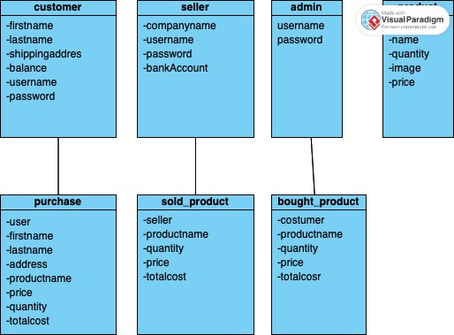

# Use case diagram

# Web API class diagram

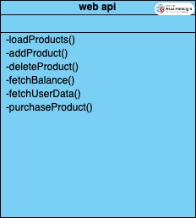

# Implementation

# use case 1 - 5

# didn’t do use case 6 because doctor allowed to remove one function

# Testing

# Use case 1

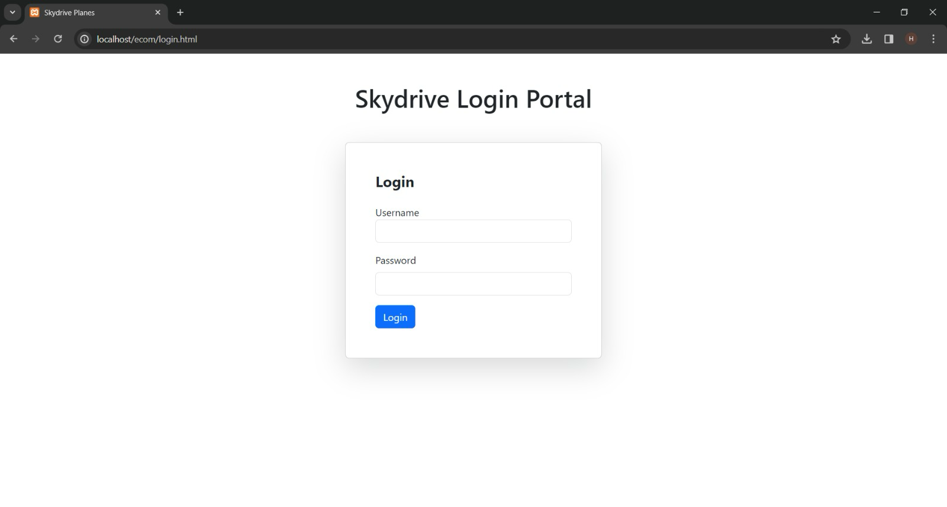use case 1 : log in

Use case 1 : log in successful

# Use case 2

Use case 2 : search for items

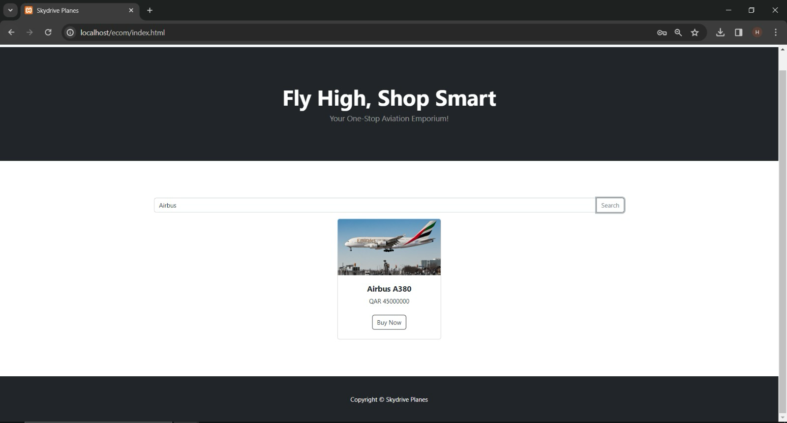

Use Case 2 : Search for "Airbus"

# Use case 3

Use Case 3 : Purchase Item [Buying Airbus A380]

Use Case 3 : Payment Successful

# Use case 4

Use Case 4 : Purchase History

# Use case 5

Use Case 5 : A seller should be able to see the list of items he/she is currently selling and the items that have been already sold.

Use Case 5 : He/She should be able to click the item and see its details. In the sale history section, how many items are sold, who bought it (username), and its selling price should appear.

# Discussion of the project contribution of each team member

in this project, my teammate and I collaborated closely through online meetings. We studied together, dividing tasks evenly and leveraging our combined strengths to achieve project goals efficiently. And if one task was tricky for one of use the other one helped with his skills.